**Task 19: Setup minikube at your local and explore creating namespaces (Go through official documentation)**

**MINIKUBE**

1. **Launch an instance:**

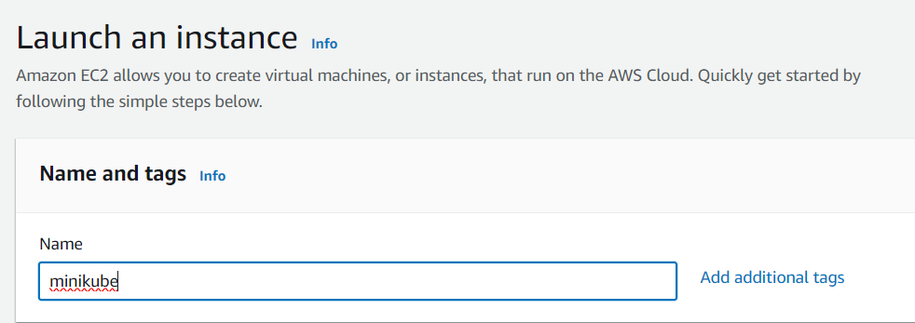

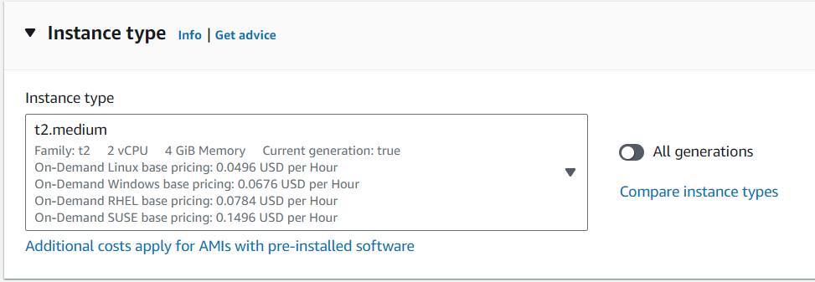

1. **Install docker:**

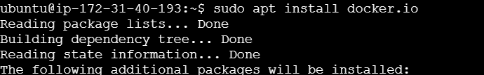

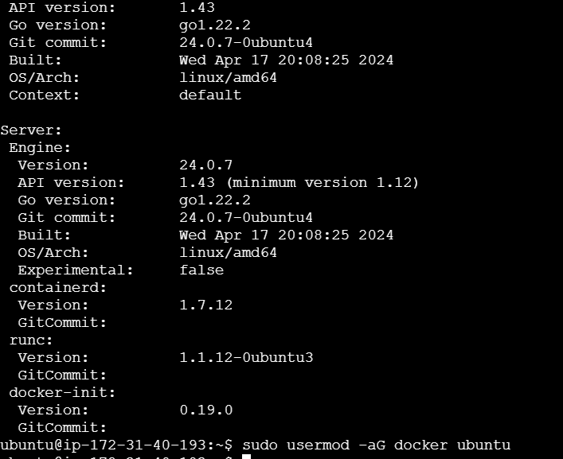

1. **Install kubectl**

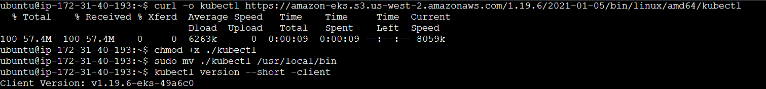

1. **Install eksctl:**



1. **Install minikube:**

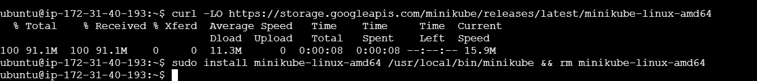

1. **Start minicube:**

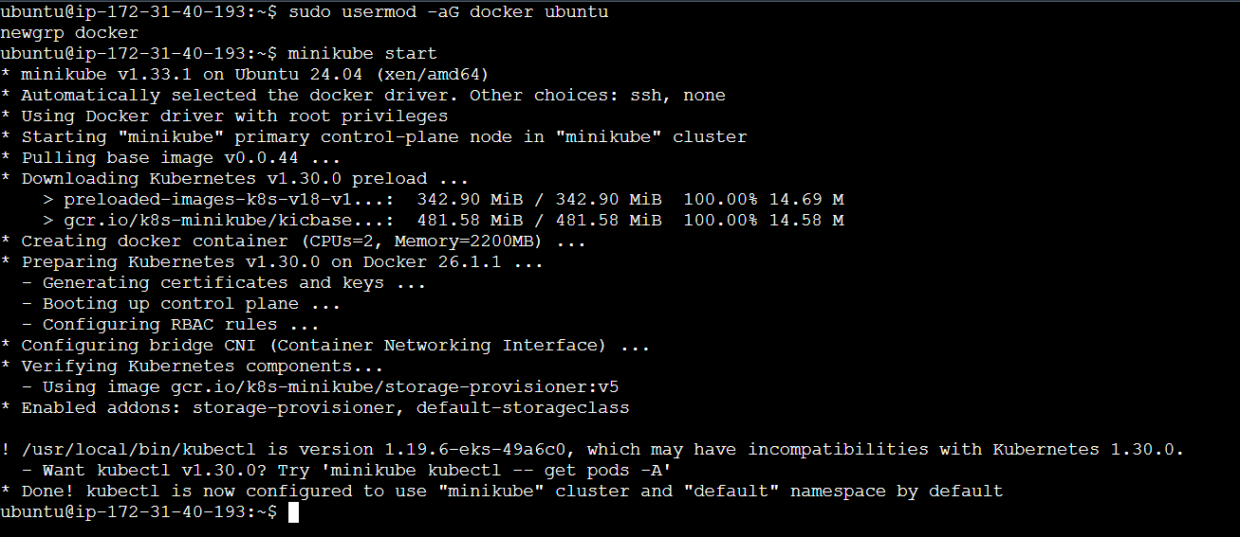

1. **Minikube status:**

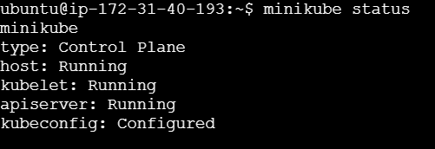

**NAMESPACE**

1. **Namespace:**
2. **Create custom namespace:**

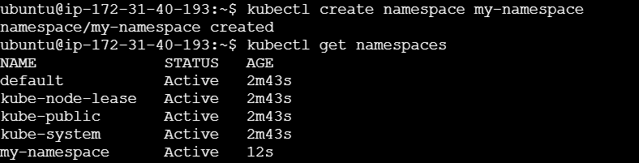

1. **Namespace.yaml file:[ use kubectl / namespace.yaml for creating namespace]**



